
Career Readiness Project: Important Instructions

Hello! You have selected the Career Readiness Project to fulfill your project requirement for English IV at the American School. Please carefully read all materials in the project folder, but note that I am making the following changes to the project requirements:
You should still read and view all the content in the project folder, but you are required to submit only the following assignments:
- Viewing Activity 3 (in Part 2: Viewing): Create a Job Search Log and Write a Summary.
Do not create the graphic organizer for the Job Search Log. I have created one for you (see “Job Search Log” in the project folder); you should fill in the information (on the five or more jobs you researched) on this spreadsheet. If you do not have access to Excel, open the PDF version of the Job Search Log and recreate that chart in the software of your choice.
*Rubrics: Graphic Organizer Rubric (Ideas or Events and Use of Language categories only); Summary Rubric
- Viewing Activity 6 (in Part: 2 Viewing, be sure to do Viewing Activity 5 first):
Request a Letter of Recommendation or a Reference Letter
*Rubric: Business Letter Rubric
- Create a Resume (in Part 3: Responding): Choose one of the following:
  - Choice 1: Create a Resume and Cover Letter
  - Choice 2: Create a Traditional and an Infographic Resume
*Rubrics: Cover Letter and Resume Rubric; Infographic Resume Rubric
*Note: Rubrics can be found in the zipped folder that contains the project’s essential documents.
At this point, you probably aren’t sure what these assignments entail. That’s OK. Print out this document and look for the assignments as you read/view the content in the project folder. When you find the assignments listed above, carefully read the instructions (and the corresponding rubric[s], if applicable) before you attempt the assignment.

How Your Project Is Graded
- You will need to earn a passing score on the project rubric, which combines your scores from the rubrics from the individual assignments).
- To view the project rubric, click on the Career Readiness Project Assignment link and then the Rubric link at the bottom of the screen, as shown below:

Step 1: | Step 2:
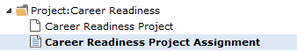 | 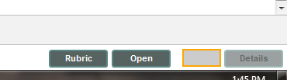
Project Rubric (i.e. Grading criteria) will display in course:
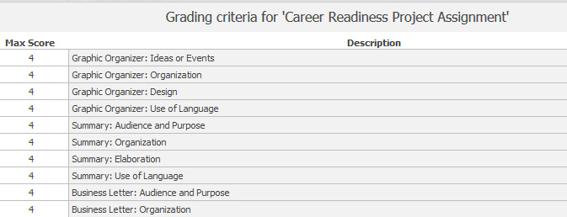

I recommend not rushing through the assignments, as you may miss important steps and need to redo your work. You can redo the assignments as many times as necessary until you earn a passing grade. However, you should attempt to do a good job on the first try. You will end up doing less work and will finish the project sooner.
After you have carefully read these instructions and all documents for the Career Readiness Project, let me know if you have any questions.
Submitting Your Work
You will submit your completed assignments in the attachments area of this project. Follow the steps on the next page:

1) Click on the “Career Readiness Project Assignment” icon
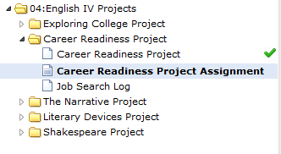
2.) On the lower right hand corner of the screen, there will be a button that says “Open.” Click on that button:
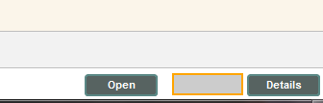
3.) Click “Browse” to attach a file from your computer (click on “Add attachment” to attach additional files):
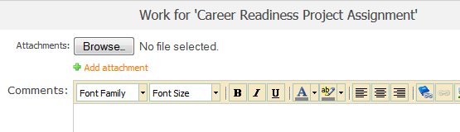
4.) Click “Submit” to submit your work (“Save” saves your attachment without submitting it for grading).
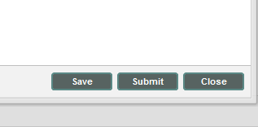
I hope you learn a lot from this project, and I look forward to reviewing your work!
--Mrs. Gordon

